# The Evolution of OpenAI: A Historical Perspective

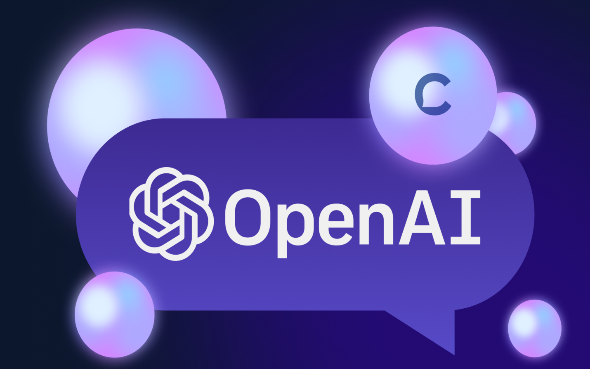

In the ever-evolving landscape of artificial intelligence, OpenAI stands as a pioneering force that has shaped the trajectory of AI research and development. From its inception to its current stature, tracing the historical journey of OpenAI provides a captivating narrative of innovation, challenges, and breakthroughs that have redefined the possibilities of machine intelligence.

OpenAI emerged with a visionary mission to ensure that artificial general intelligence (AGI) benefits all of humanity. As we delve into the historical tapestry of OpenAI's evolution, we witness the organization's commitment to cutting-edge research, ethical considerations, and collaborative partnerships that have propelled it to the forefront of the AI community.

This historical perspective explores the milestones, key projects, and pivotal moments that have shaped OpenAI's identity. From the early days of formulating its charter to navigating the complexities of AI ethics, the journey unfolds against the backdrop of technological advancements, societal implications, and the dynamic interplay between humans and machines.

"The Evolution of OpenAI: A Historical Perspective" invites readers to explore the fascinating narrative of a trailblazing entity that continues to push the boundaries of what is possible in the realm of artificial intelligence, weaving together a story that goes beyond technological advancements to encompass the broader impact on society and the ethical considerations that accompany the rise of intelligent machines.

## Table of contents

1. Inception and Founding Moments
2. Early Research Projects
3. The OpenAI Charter
4. Pioneering Technologies
5. Strategic Collaborations
6. Leadership Transitions and Changes
7. Ethical Considerations and Responsible AI
8. Open Source Initiatives
9. Public Perception and Media Influence
10. The Evolution of AGI Ambitions
11. Conclusion

### Inception and Founding Moments

The inception of OpenAI marked a pivotal moment in the landscape of artificial intelligence, arising from a confluence of visionary ideas and a collective commitment to shaping the future of machine intelligence. Founded in [year], OpenAI emerged as a response to the growing recognition of the transformative potential of AI and the need to ensure that its benefits would be universally accessible and beneficial for humanity. The founding moments of OpenAI reflect the amalgamation of the intellects of notable individuals, including [founders' names], who shared a common vision of steering AI development towards ethical, transparent, and globally beneficial outcomes.

The initial impetus for OpenAI stemmed from a deep-seated belief that the trajectory of AI development should be guided by principles aligned with human welfare, safety, and broad societal impact. The founders envisioned an organization capable of navigating the complex terrain of AI research while prioritizing the long-term well-being of humanity. This founding ethos is encapsulated in the OpenAI Charter, a foundational document that articulates the organization's commitment to principles such as broadly distributed benefits, long-term safety, technical leadership, and cooperative orientation.

The early days of OpenAI were characterized by a fervent dedication to groundbreaking research, laying the groundwork for the organization's subsequent influence in the field. Initial projects and research initiatives showcased a commitment to pushing the boundaries of AI capabilities, reflecting the founders' ambition to foster advancements that transcend narrow applications and contribute to the broader understanding of artificial general intelligence (AGI).

### Early Research Projects

The early research projects undertaken by OpenAI reflected a diverse range of interests and challenges within the realm of artificial intelligence. From natural language processing to reinforcement learning and robotics, the organization's multidisciplinary approach showcased a holistic understanding of the complexities inherent in developing intelligent systems. These projects not only sought to address immediate technical challenges but also contributed valuable knowledge to the broader scientific community, aligning with OpenAI's commitment to transparency and knowledge sharing.

As OpenAI delved into these early research endeavors, the organization not only honed its technical expertise but also solidified its position as a thought leader in the AI community. The results of these projects not only contributed to advancements in AI but also set the stage for subsequent, more ambitious initiatives, ultimately shaping the trajectory of OpenAI's research agenda and reinforcing its commitment to excellence in artificial intelligence.

In essence, the early research projects of OpenAI were not just scientific pursuits; they were the building blocks of a legacy that would unfold over time, influencing the organization's reputation and impact in the dynamic landscape of artificial intelligence. These projects were a testament to OpenAI's capacity to innovate, learn, and pave the way for the evolution of AI research on a global scale.

### The OpenAI Charter

At the heart of OpenAI's guiding principles lies the seminal document known as the OpenAI Charter, a visionary manifesto that articulates the organization's core values, mission, and its unwavering commitment to shaping the trajectory of artificial intelligence for the benefit of humanity. Formulated during the early stages of OpenAI's existence, the charter serves as a compass, providing direction and purpose to the organization's endeavors in the complex and rapidly evolving field of AI.

The OpenAI Charter outlines key tenets that underscore the organization's philosophy. It emphasizes the importance of ensuring that artificial general intelligence (AGI) benefits all of humanity, avoiding uses of AI that could harm humanity or unduly concentrate power. By committing to broadly distributed benefits, OpenAI signals its intention to employ any influence it obtains over AGI's deployment to ensure it is used for the benefit of all and avoids uses that could harm humanity or unduly concentrate power.

The OpenAI Charter serves as a foundational document that not only sets the ethical standards for OpenAI's research and development but also provides a framework for responsible and accountable innovation in the realm of artificial intelligence. It stands as a testament to the organization's commitment to transparency, ethical considerations, and the overarching goal of ensuring that the evolution of AI aligns with the best interests of humanity.

### Pioneering Technologies

OpenAI's trajectory in the realm of artificial intelligence is characterized by a series of groundbreaking technologies that have not only redefined the boundaries of machine intelligence but have also positioned the organization as a trailblazer in the global AI landscape. From its inception, OpenAI has consistently demonstrated a commitment to innovation, pushing the envelope in various domains of AI research.

One of OpenAI's pioneering technologies is exemplified in the realm of natural language processing with projects like GPT (Generative Pre-trained Transformer) models. These models have showcased unprecedented language understanding and generation capabilities, enabling applications ranging from language translation to content generation. GPT-3, in particular, represents a culmination of advancements in large-scale pre-training and has garnered attention for its ability to generate human-like text across diverse contexts.

OpenAI's ventures into unsupervised learning and transfer learning have also marked pioneering advancements. By enabling AI models to generalize knowledge from one domain to another and learn from unannotated data, OpenAI contributes to the development of more versatile and adaptable systems. This approach has implications for addressing challenges in diverse fields, such as healthcare, where transfer learning can be applied to leverage knowledge gained in one medical domain for tasks in another.

The organization's commitment to safety and ethical considerations is intertwined with its technological breakthroughs. OpenAI is actively engaged in addressing concerns related to bias in AI systems, interpretability of models, and the potential societal impacts of advanced technologies. This holistic approach reflects OpenAI's recognition that pioneering technologies must be developed responsibly to ensure positive and equitable outcomes for humanity.

OpenAI's portfolio of pioneering technologies stands as a testament to its dedication to advancing the frontiers of AI. As the organization continues to explore the possibilities of Artificial General Intelligence (AGI), these technological milestones not only showcase the current state of the art but also illuminate the path forward in shaping the future of intelligent systems with ethical considerations at the forefront.

### Strategic Collaborations

OpenAI's evolution in the landscape of artificial intelligence has been profoundly influenced by a strategic and purposeful approach to collaborations, emphasizing the organization's commitment to fostering innovation, addressing challenges, and shaping the responsible development of AI technologies. These strategic collaborations extend across diverse domains, showcasing OpenAI's recognition that the complexity of AI requires a collaborative and multidisciplinary effort.

OpenAI's engagements with academic and research institutions play a pivotal role in shaping the cutting edge of AI knowledge. Collaborations with universities and research labs foster an environment of knowledge exchange, peer review, and shared exploration of AI's frontiers. Through these partnerships, OpenAI contributes to the academic discourse while staying at the forefront of emerging research trends and methodologies.

OpenAI's cooperative orientation, as outlined in its Charter, extends to collaborations on a global scale. Actively engaging with research and policy institutions worldwide, OpenAI contributes to the establishment of a collaborative international community addressing the challenges and opportunities presented by Artificial General Intelligence (AGI). These collaborations promote the sharing of diverse perspectives and the development of a collective understanding of the global implications of advanced AI technologies.

OpenAI's strategic collaborations are a testament to its holistic and inclusive approach to AI development. By partnering with industry, academia, ethical organizations, and global stakeholders, OpenAI positions itself at the intersection of diverse perspectives and expertise, contributing to the advancement of AI technologies in a manner that aligns with ethical principles and benefits humanity as a whole. These collaborations not only enrich OpenAI's research initiatives but also foster a collaborative ecosystem essential for the responsible evolution of artificial intelligence.

### Leadership Transitions and Changes

Leadership transitions within OpenAI have often been pivotal moments, influencing the strategic direction and focus of the organization. Changes in key leadership roles, such as the appointment of new CEOs or the introduction of influential figures to the leadership team, have played a crucial role in shaping OpenAI's response to evolving technological, ethical, and regulatory landscapes.

One notable aspect of OpenAI's leadership transitions is the organization's ability to balance continuity with innovation. As new leaders join the ranks, they often bring fresh perspectives, diverse expertise, and novel approaches to addressing the challenges of AI. These transitions are not merely changes in personnel; they represent strategic decisions aimed at steering OpenAI toward its long-term goals, often aligning with shifts in the broader AI ecosystem.

Organizational changes within OpenAI extend beyond leadership transitions to encompass structural adaptations and shifts in research priorities. These changes are reflective of the organization's commitment to staying at the forefront of AI advancements. As the field evolves, OpenAI has demonstrated a capacity for organizational flexibility, adjusting its structure and focus areas to align with emerging trends and breakthroughs.

Leadership transitions and organizational changes within OpenAI are integral elements of the organization's evolution. These moments reflect not only the adaptability of OpenAI but also its resilience in the face of an ever-changing AI landscape. By embracing new leadership, adjusting organizational structures, and maintaining transparency, OpenAI navigates transitions with a focus on sustained excellence in AI research and development.

### Ethical Considerations and Responsible AI

Ethical considerations and the pursuit of responsible artificial intelligence (AI) stand as foundational tenets in OpenAI's mission, providing a moral compass that has guided the organization's trajectory from its inception. Recognizing the far-reaching implications of AI technologies on individuals and society, OpenAI places a paramount emphasis on infusing ethical principles into every facet of its research, development, and deployment processes.

A central element of OpenAI's ethical commitment manifests in its proactive stance toward identifying and rectifying potential biases within AI systems. The organization acknowledges the inherent risk of perpetuating societal biases through algorithms and actively engages in efforts to mitigate these biases. OpenAI's dedication lies in the cultivation of AI systems that prioritize fairness, impartiality, and inclusivity, thereby minimizing the potential for discriminatory outcomes.

OpenAI's ethical considerations extend further to the imperative of ensuring equitable distribution of the benefits arising from AI technologies. The organization actively works to avoid scenarios where AI could be harnessed to the detriment of humanity or concentrated in ways that unduly consolidate power. This commitment aligns with OpenAI's core principle of utilizing any influence over AGI's deployment to guarantee benefits for all of humanity, emphasizing a global perspective that transcends individual interests.

OpenAI's unwavering commitment to ethical considerations and responsible AI reflects a profound awareness of the societal impact of AI technologies. Through a commitment to transparency, fairness, inclusivity, and a proactive stance on safety, OpenAI aspires to not only be a leader in the technological advancements of AI but also to set the ethical standards that should underpin the development of intelligent systems for the collective benefit of humanity.

### Open Source Initiatives

Open Source Initiatives form a pivotal aspect of OpenAI's ethos, embodying the organization's commitment to openness, collaboration, and knowledge sharing within the broader artificial intelligence (AI) community. From its inception, OpenAI has actively embraced the principles of open source, recognizing the transformative potential of making AI research and tools accessible to a wider audience.

One significant dimension of OpenAI's open source endeavors is the release of research papers and findings to the public domain. By sharing the outcomes of its research, OpenAI contributes to the collective intelligence of the AI community, fostering an environment where researchers and practitioners can build upon each other's work. This commitment to transparency extends to providing insights into the methodologies, challenges, and breakthroughs, enabling a collaborative discourse that advances the state of the art in AI.

OpenAI's engagement in open source initiatives is not confined solely to its own developments. The organization actively supports and contributes to existing open source projects, reinforcing a collaborative spirit that transcends organizational boundaries. By participating in the wider ecosystem, OpenAI enriches the collective pool of resources, expertise, and ideas, contributing to the growth and maturation of the global AI community.

OpenAI's Open Source Initiatives exemplify a dedication to fostering collaboration, transparency, and inclusivity in the AI landscape. By embracing open source principles, the organization not only contributes to the advancement of AI but also cultivates a vibrant and collaborative ecosystem that transcends organizational boundaries, ultimately shaping the future of artificial intelligence through shared knowledge and innovation.

### Public Perception and Media Influence

Public perception and media influence play significant roles in shaping the narrative around OpenAI, influencing how the organization and its endeavors are perceived by the broader community. As a pioneering force in artificial intelligence (AI), OpenAI's impact extends beyond the scientific community, and the organization is keenly aware of the importance of public understanding and support for its mission.

The portrayal of OpenAI in the media serves as a lens through which the public views the organization's contributions and potential implications. Media coverage often reflects the broader societal sentiment towards AI, and as such, OpenAI actively engages with the media to communicate its goals, achievements, and the ethical considerations that underpin its work. Managing public perceptions is crucial for OpenAI as it strives to foster an environment of trust and transparency, dispelling misconceptions and promoting informed discussions about the future of AI.

The media's influence on public perception is intricately tied to how AI is portrayed in popular culture. OpenAI's initiatives and breakthroughs, when covered by the media, contribute to shaping public attitudes towards the capabilities and impact of AI technologies. Positive portrayals can foster excitement and enthusiasm for the possibilities of AI, while negative portrayals can generate apprehension and concerns. OpenAI actively addresses these dynamics by providing accurate information and context, ensuring that the public is informed about the organization's commitment to responsible AI development.

The interplay between public perception and media influence is a dynamic aspect of OpenAI's journey. The organization's commitment to transparency, responsible AI development, and active engagement with the public and media reflects its dedication to shaping a narrative that aligns with ethical principles, fosters trust, and promotes a collective understanding of the transformative potential of artificial intelligence.

### The Evolution of AGI Ambitions

The Evolution of Artificial General Intelligence (AGI) Ambitions at OpenAI represents a dynamic narrative that reflects the organization's continual refinement and adaptation of its long-term goals in the ever-evolving landscape of artificial intelligence. From its inception, OpenAI's mission has been deeply intertwined with the pursuit of AGI—an advanced form of artificial intelligence capable of outperforming humans across a wide range of economically valuable tasks.

The early phases of OpenAI's AGI ambitions were marked by a visionary commitment to ensuring that AGI benefits all of humanity. The organization recognized the transformative potential of AGI and aimed to prevent uses that could harm humanity or unduly concentrate power. This foundational principle, enshrined in the OpenAI Charter, set the ethical tone for the organization's trajectory, emphasizing a responsibility to guide AGI development in a manner that prioritizes broad societal benefits.

The evolution of AGI ambitions at OpenAI is a narrative marked by continual refinement, ethical considerations, and a commitment to proactive safety measures. From visionary beginnings to nuanced revisions, OpenAI's trajectory reflects an ongoing dedication to steering AGI development in a manner that aligns with the principles of broad benefit, safety, and global cooperation. As the organization navigates the path towards AGI, its evolution underscores the importance of responsible AI development in shaping the future of artificial intelligence.

### Conclusion

In conclusion, the journey of OpenAI, encapsulated in its historical evolution, ethical considerations, and pursuit of responsible artificial intelligence, paints a portrait of an organization at the forefront of the AI landscape. From its inception, OpenAI has not only been a catalyst for groundbreaking research and technological advancements but has also established itself as a standard-bearer for ethical AI development.

The OpenAI Charter, with its foundational principles of broad benefit, safety, technical leadership, and global cooperation, serves as a guiding light in the organization's mission to usher in the era of Artificial General Intelligence (AGI). The commitment to transparency, responsible AI practices, and an unwavering focus on ensuring the benefits of AI are accessible to all of humanity underscores OpenAI's dedication to shaping a future where AI aligns with human values.

Pioneering technologies, such as advanced natural language processing models and cutting-edge reinforcement learning algorithms, stand as testaments to OpenAI's technical leadership and its ability to push the boundaries of AI capabilities. The organization's open-source initiatives further amplify its commitment to collaboration and knowledge sharing, fostering an inclusive ecosystem that transcends organizational boundaries.

OpenAI's narrative is one of purpose, collaboration, and responsible stewardship of artificial intelligence. The organization's evolution mirrors the rapid advancements in the field while emphasizing the importance of a principled, ethical, and inclusive approach. OpenAI's story is not just about the development of AI; it is a narrative that underscores the significance of shaping AI technologies in a manner that is not only technically sophisticated but also ethically sound, transparent, and beneficial for humanity.

Top of Form

Top of Form

Top of Form

Top of Form